**JUnit**

**@Test** - To mark a method as a test method

**@Test(expected=ExceptionClassName.class)** - To mark a method for the exception scenario

**@Before** - Will excute before each test method

**@After** - Will execute after each test method

**@BeforeClass** - Will run before entire test class

**@AfterClass** - Will run after entire test class

**@Ignore** - If we use this annontation on the method that method will be ignored

**static org.junit.Assert.\*** - To use the static assert methods

Return type of every Assert method is void

**Methods of Assert:**

1. void assertNull(Object obj) - Checks that the object is null

2. void assertNotNull(Object obj) - Checks that the object is not null

3. void assertEquals(boolean expected, boolean actual) - Checks that two primitives/objects are equal

4. void assertTrue(boolean condition) - Checks that the condition is true

5. void assertFalse(boolean condition) - Checks that the condition is false

6. void assertSame(obj1, obj2) - Checks that two object references are pointing to the same Object

7. void assertNotSame(obj1, obj2) - checks that two object references are not pointing to the same Object

8. void assertArrayEquals(expectedArray, actualArray) - Checks that the two arrays are equal

@RunWith(SpringJUnit4ClassRunner.class)

It extends BlockJUnit4ClassRunner.class

Implements JunitRunner framework for writing Integration Test

**Example:**

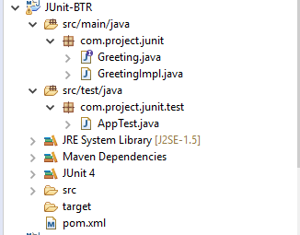

**Greeting.java**

package com.project.junit;

public interface Greeting

{

public String greet(String name);

}

**GreetingImpl.java**

package com.project.junit;

public class GreetingImpl implements Greeting

{

public String greet(String name)

{

if(name==null || name.length()==0)

{

throw new IllegalArgumentException();

}

return "Hello "+name;

}

}

**App.java**

package com.project.junit.test;

import static org.junit.Assert.*;

import org.junit.After;

import org.junit.Before;

import org.junit.Test;

import com.project.junit.Greeting;

import com.project.junit.GreetingImpl;

**public class AppTest**

{

private Greeting gi;

@Before

public void setUp()

{

System.err.println("setUp");

gi = new GreetingImpl();

}

@After

public void tearDown()

{

System.err.println("tearDown");

gi=null;

}

@Test

public void greetShouldReturnValidOuptut()

{

System.err.println("greetShouldReturnValidOuptut");

String result = gi.greet("JUnit");

assertNotNull(result);

assertEquals("Hello JUnit", result);

}

@Test(expected = IllegalArgumentException.class)

public void greetShouldThrowIllegalArgumentExceptionIfNameIsNull()

{

System.err.println("greetShouldThrowIllegalArgumentExceptionIfNameIsNull");

gi.greet(null);

}

@Test(expected = IllegalArgumentException.class)

public void greetShouldThrowIllegalArgumentExceptionIfNameIsEmpty()

{

System.err.println("greetShouldThrowIllegalArgumentExceptionIfNameIsEmpty");

gi.greet("");

}

}

**Output:**

All unit test is passed

setUp

greetShouldThrowIllegalArgumentExceptionIfNameIsEmpty

tearDown

setUp

greetShouldThrowIllegalArgumentExceptionIfNameIsNull

tearDown

setUp

greetShouldReturnValidOuptut

tearDown

Test Coverage / Code Coverage:

______________________________

TC or CC is the number of lines of our source code that is tested whenever unit tests are run against the source code.

We measure CC using tools.

Popular Tools:

1. EclEmma

2. Cobertura

3. JTest

Parameterized Test

To use parameterized test we have to annotate the class name with @RunWith(Parameterized.class)

We can use parameterized test for testing a single method with different scenarios or inputs

Simple Example

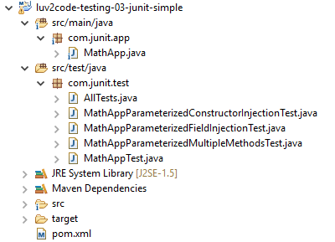

pom.xml

<project xmlns="http://maven.apache.org/POM/4.0.0" xmlns:xsi="http://www.w3.org/2001/XMLSchema-instance"

xsi:schemaLocation="http://maven.apache.org/POM/4.0.0 http://maven.apache.org/xsd/maven-4.0.0.xsd">

<modelVersion>4.0.0</modelVersion>

<groupId>junit.mockito</groupId>

<artifactId>luv2code-testing-03-junit-simple</artifactId>

<version>0.0.1-SNAPSHOT</version>

<packaging>jar</packaging>

<name>luv2code-testing-03-junit-simple</name>

<url>http://maven.apache.org</url>

<properties>

<project.build.sourceEncoding>UTF-8</project.build.sourceEncoding>

</properties>

<dependencies>

<dependency>

<groupId>junit</groupId>

<artifactId>junit</artifactId>

<version>4.12</version>

<scope>test</scope>

</dependency>

</dependencies>

</project>

MathApp.java

package com.junit.app;

public class MathApp

{

public int add(int a, int b)

{

System.out.println("a = "+a+" b = "+ b + " Sum of a and b = " + (a+b));

return a+b;

}

public int sub(int a, int b)

{

System.out.println("a = "+a+" b = "+ b + " Substraction of a and b = " + (a-b));

return a-b;

}

public int mul(int a, int b)

{

System.out.println("a = "+a+" b = "+ b + " Multiplication of a and b = " + (a*b));

return a*b;

}

}

MathAppTest.java

package com.junit.test;

import static org.junit.Assert.*;

import org.junit.After;

import org.junit.Before;

import org.junit.Test;

import com.junit.app.MathApp;

public class MathAppTest

{

private MathApp mathApp;

// This method will be executed before the execution of each test method

@Before

public void setUp()

{

mathApp=new MathApp();

}

// This method will be executed after the execution of each test method

@After

public void tearDown()

{

mathApp=null;

}

@Test

public void testAddWithPositiveNumber()

{

assertEquals(9,mathApp.add(4, 5));

}

@Test

public void testAddWithNegativeNumber()

{

assertEquals(-1,mathApp.add(4, -5));

}

@Test

public void testSubWithPositiveNumber()

{

assertEquals(1,mathApp.sub(5, 4));

}

@Test

public void testSubWithNegativeNumber()

{

assertEquals(9,mathApp.sub(5, -4));

}

@Test

public void testMulWithPositiveNumber()

{

assertEquals(20,mathApp.mul(5, 4));

}

@Test

public void testMulWithNegativeNumber()

{

assertEquals(-20,mathApp.mul(5, -4));

}

}

MathAppParameterizedConstructorInjection.java

package com.junit.test;

import static org.hamcrest.CoreMatchers.is;

import static org.junit.Assert.*;

import java.util.Arrays;

import java.util.Collection;

import org.junit.After;

import org.junit.Before;

import org.junit.Test;

import org.junit.runner.RunWith;

import org.junit.runners.Parameterized;

import org.junit.runners.Parameterized.Parameters;

import com.junit.app.MathApp;

@RunWith(value = Parameterized.class)

public class MathAppParameterizedConstructorInjectionTest

{

private MathApp mathApp;

private int actualInput1;

private int actualInput2;

private int expectedOutput;

public MathAppParameterizedConstructorInjectionTest(int actualInput1, int actualInput2, int expectedOutput)

{

this.actualInput1 = actualInput1;

this.actualInput2 = actualInput2;

this.expectedOutput = expectedOutput;

}

// This method will be executed before the execution of each test method

@Before

public void setUp()

{

mathApp = new MathApp();

}

// This method will be executed after the execution of each test method

@After

public void tearDown()

{

mathApp = null;

}

/*@Parameters(name="{index}: testAdd({0}+{1})={2}")

public static Collection<Object[]> testData()

{

return Arrays.asList(new Object[][] { { 1, 1, 2 }, { 5, 6, 11 } });

}*/

@Parameters

public static Collection<Integer[]> testData()

{

Integer expectedOuputs[][] = { {5,5,10},{5,4,9} };

return Arrays.asList(expectedOuputs);

}

@Test

public void testAddition()

{

assertThat(mathApp.add(actualInput1,actualInput2), is(expectedOutput));

}

}

MathAppParameterizedFieldInjection.java

package com.junit.test;

import static org.hamcrest.CoreMatchers.is;

import static org.junit.Assert.*;

import java.util.Arrays;

import java.util.Collection;

import org.junit.After;

import org.junit.Before;

import org.junit.Test;

import org.junit.runner.RunWith;

import org.junit.runners.Parameterized;

import org.junit.runners.Parameterized.Parameter;

import org.junit.runners.Parameterized.Parameters;

import com.junit.app.MathApp;

@RunWith(value = Parameterized.class)

public class MathAppParameterizedFieldInjectionTest

{

// Field Injection the fields should be public

private MathApp mathApp;

@Parameter(value=0)

public int actualInput1;

@Parameter(value=1)

public int actualInput2;

@Parameter(value=2)

public int expectedOutput;

// This method will be executed before the execution of each test method

@Before

public void setUp()

{

mathApp = new MathApp();

}

// This method will be executed after the execution of each test method

@After

public void tearDown()

{

mathApp = null;

}

/*@Parameters(name="{index}: testAdd({0}+{1})={2}")

public static Collection<Object[]> testData()

{

return Arrays.asList(new Object[][] { { 1, 1, 2 }, { 5, 6, 11 } });

}*/

@Parameters(name="{index}: testAdd({0}+{1})={2}")

public static Collection<Integer[]> testData()

{

Integer expectedOuputs[][] = { {5,5,10},{5,4,9} };

return Arrays.asList(expectedOuputs);

}

@Test

public void testAdd()

{

assertThat(mathApp.add(actualInput1,actualInput2), is(expectedOutput));

}

}

MathAppParameterizedMultipleMethods.java

package com.junit.test;

import static org.hamcrest.CoreMatchers.is;

import static org.junit.Assert.*;

import java.util.Arrays;

import java.util.Collection;

import org.junit.After;

import org.junit.Assume;

import org.junit.Before;

import org.junit.Test;

import org.junit.runner.RunWith;

import org.junit.runners.Parameterized;

import org.junit.runners.Parameterized.Parameters;

import com.junit.app.MathApp;

@RunWith(value = Parameterized.class)

public class MathAppParameterizedMultipleMethodsTest

{

private MathApp mathApp;

enum MethodType {SUBSTRACTION, ADDITION, MULTIPLICATION};

private int actualInput1;

private int actualInput2;

private int expectedOutput;

private MethodType type;

public MathAppParameterizedMultipleMethodsTest(int actualInput1, int actualInput2, int expectedOutput, MethodType type)

{

this.actualInput1 = actualInput1;

this.actualInput2 = actualInput2;

this.expectedOutput = expectedOutput;

this.type = type;

}

// This method will be executed before the execution of each test method

@Before

public void setUp()

{

mathApp = new MathApp();

}

// This method will be executed after the execution of each test method

@After

public void tearDown()

{

mathApp = null;

}

@Parameters(name="{index}: test( {0} {3} {1} )= {2}")

public static Collection<Object[]> testData()

{

Object expectedOuputs[][] =

{

{5,5,10,MethodType.ADDITION},

{5,4,1,MethodType.SUBSTRACTION},

{5,4,20,MethodType.MULTIPLICATION},

{5,6,11,MethodType.ADDITION},

{4,-5,9,MethodType.SUBSTRACTION},

{-5,-5,25,MethodType.MULTIPLICATION}

};

return Arrays.asList(expectedOuputs);

}

@Test

public void testAdd()

{

Assume.assumeTrue(type == MethodType.ADDITION);

assertThat(mathApp.add(actualInput1,actualInput2), is(expectedOutput));

}

@Test

public void testSub()

{

Assume.assumeTrue(type == MethodType.SUBSTRACTION);

assertThat(mathApp.sub(actualInput1,actualInput2), is(expectedOutput));

}

@Test

public void testMul()

{

Assume.assumeTrue(type == MethodType.MULTIPLICATION);

assertThat(mathApp.mul(actualInput1,actualInput2), is(expectedOutput));

}

}

AllTests.java (TestSuite)

package com.junit.test;

import org.junit.runner.RunWith;

import org.junit.runners.Suite;

import org.junit.runners.Suite.SuiteClasses;

@RunWith(Suite.class)

@SuiteClasses({ MathAppParameterizedConstructorInjectionTest.class, MathAppParameterizedFieldInjectionTest.class,

MathAppParameterizedMultipleMethodsTest.class, MathAppTest.class })

public class AllTests

{

}

Output MathAppTest.java

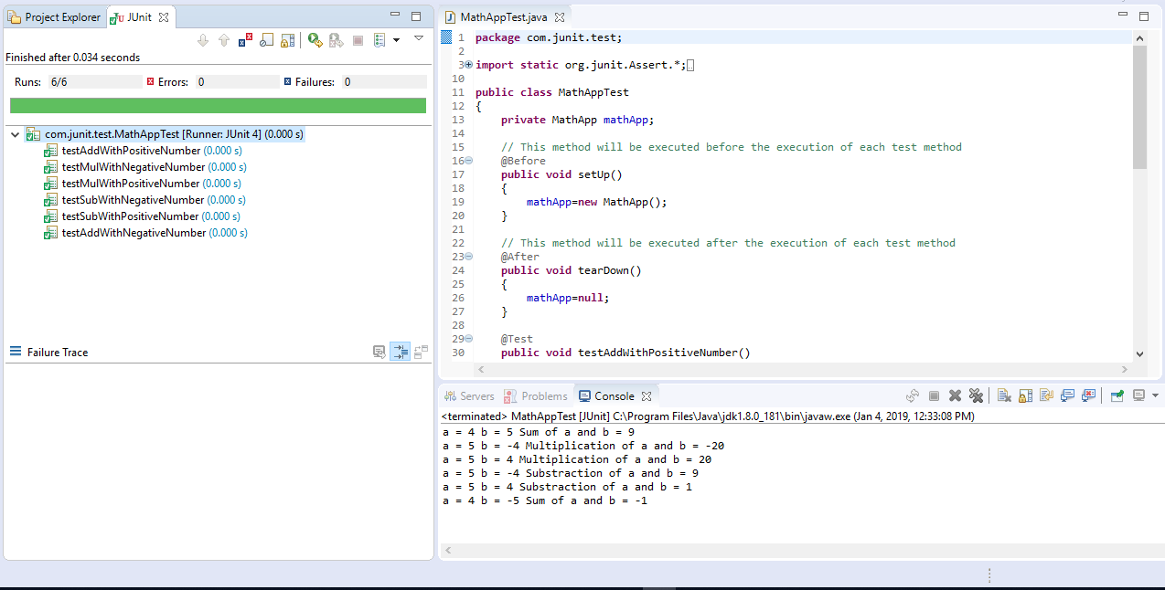

Output MathAppParameterizedConstructorInjectionTest.java

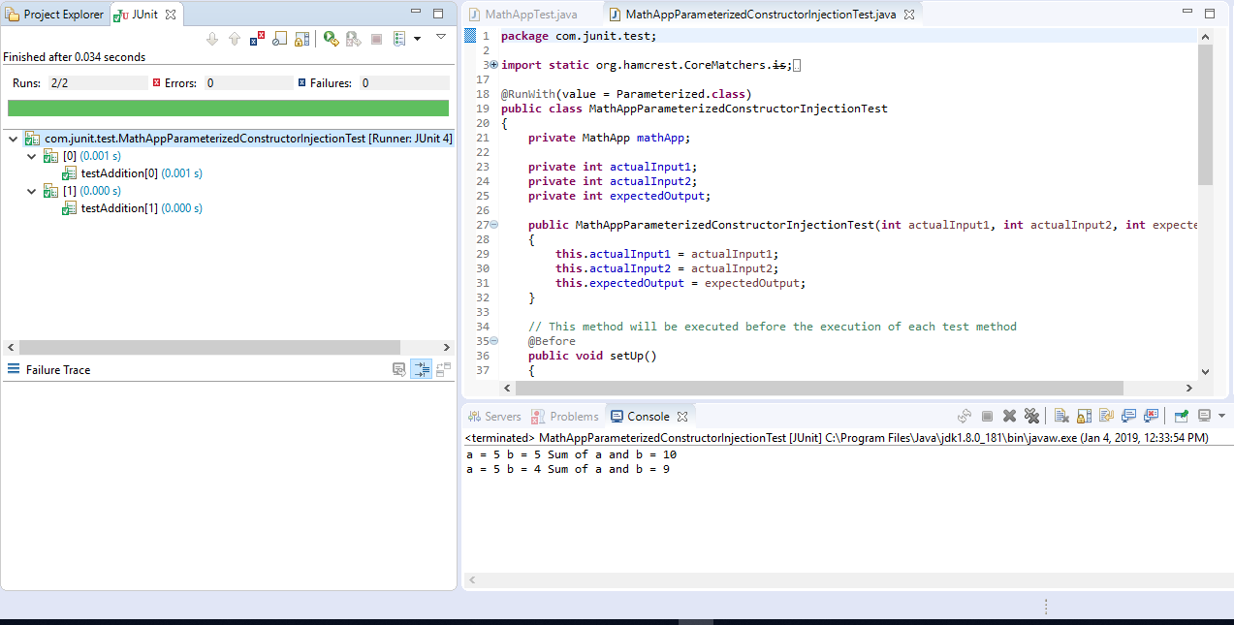

Output MathAppParameterizedFieldInjectionTest.java

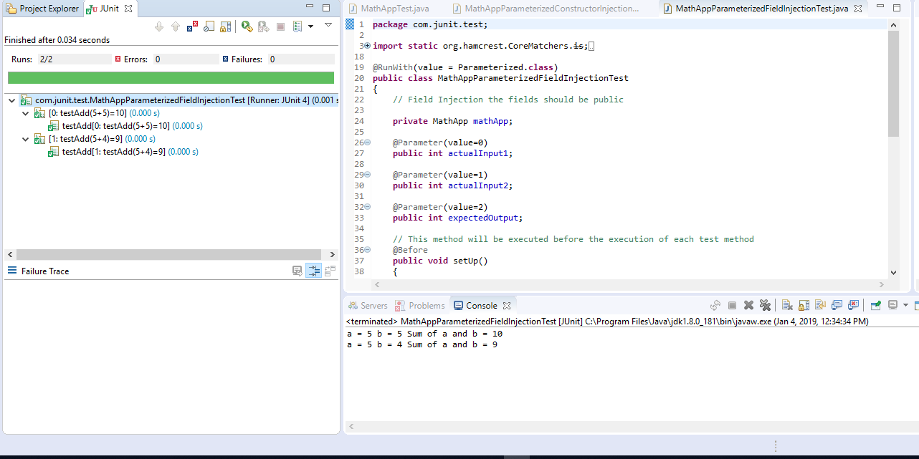

Output MathAppParameterizedMultipleMethodsTest.java

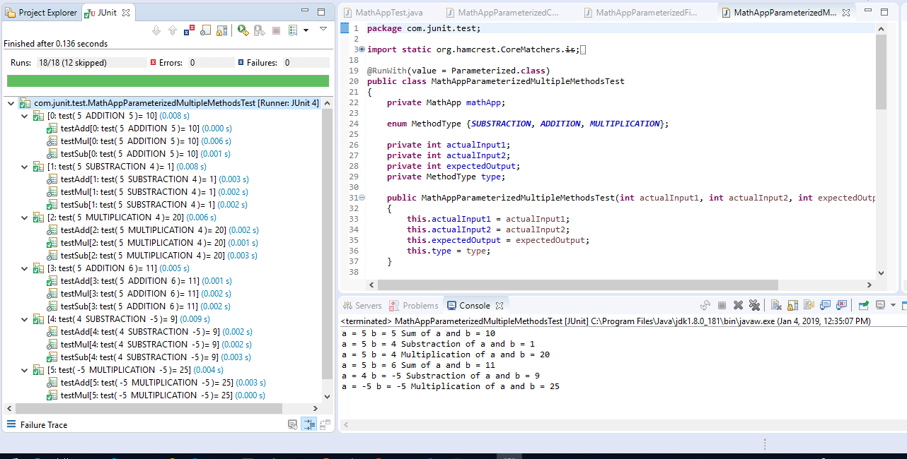

Output AllTests.java

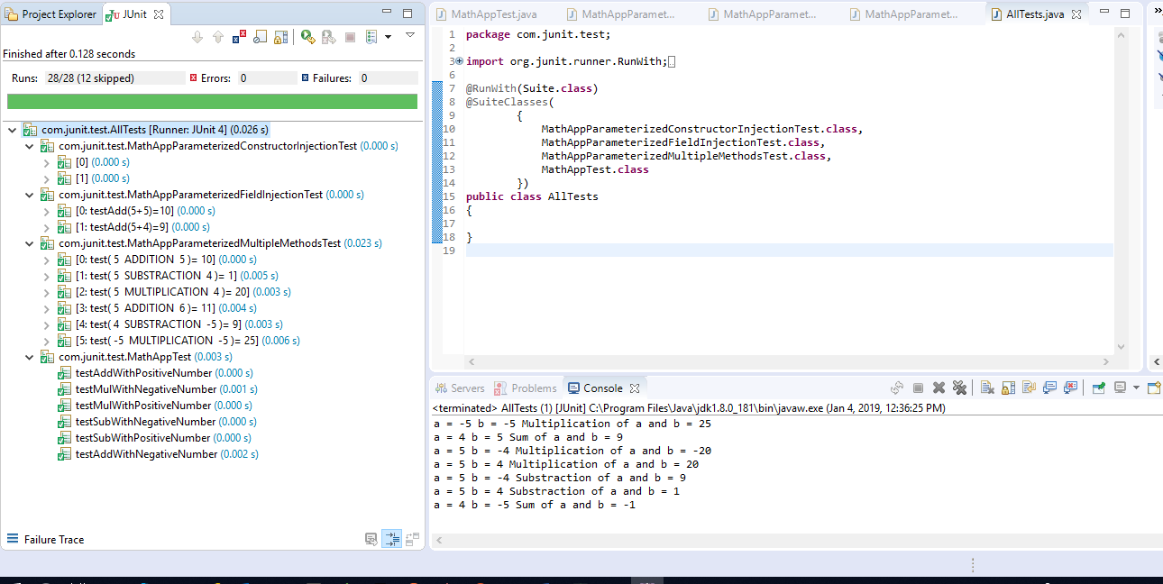

**Mockito**

**Mocking** - Testing in Isolation, Testing our code without testing our dependency(Dependencies are tested automatically)

A------------------->B Mock

**Example Scenario:**

If class A depends on or uses Class B and if we are unit testing class A then we will mockout Class B and all of its methods that class A uses.

The "**Mock**" object will takes the place of real object of Class B

ReservationController (UI Components)

|

ReservationBO (Business Logics)

|

ReservationDAO (Database Operations)

Now Testing ReservationController and mockout all the methods of ReservationBO that the controller class uses.

**Steps in Mocking**

Step 1. Stubbing

Step 2. Setting the Expectations

Step 3. Verifying

**Mockito Framework provides the ability to do the above 3 steps**

Step1 & Step2 or Stubbing & Setting the Expectations = @Mock (when, thenReturn and thenThrow, etc)

Verifying = verify, matchers, etc

**Example:**

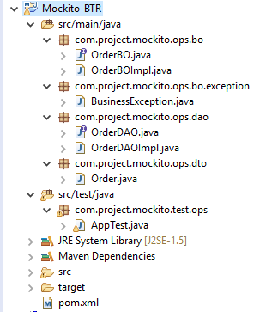

**Order.java**

package com.project.mockito.ops.dto;

public class Order

{

private int id;

private String status;

public int getId()

{

return id;

}

public void setId(int id)

{

this.id = id;

}

public String getStatus()

{

return status;

}

public void setStatus(String status)

{

this.status = status;

}

@Override

public String toString()

{

return "Order [id=" + id + ", status=" + status + "]";

}

}

**OrderBO.java**

package com.project.mockito.ops.bo;

import com.project.mockito.ops.bo.exception.BusinessException;

import com.project.mockito.ops.dto.Order;

public interface OrderBO

{

boolean createOrder(Order order)throws BusinessException;

boolean cancelOrder(int id)throws BusinessException;

boolean deleteOrder(int id)throws BusinessException;

}

**OrderBOImpl.java**

package com.project.mockito.ops.bo;

import java.sql.SQLException;

import com.project.mockito.ops.bo.exception.BusinessException;

import com.project.mockito.ops.dao.OrderDAO;

import com.project.mockito.ops.dto.Order;

public class OrderBOImpl implements OrderBO

{

private OrderDAO dao;

public OrderDAO getDao()

{

return dao;

}

public void setDao(OrderDAO dao)

{

this.dao = dao;

}

public boolean createOrder(Order order) throws BusinessException

{

try

{

int create = dao.create(order);

if(create==0)

{

return false;

}

}

catch (SQLException e)

{

throw new BusinessException(e);

}

return true;

}

public boolean cancelOrder(int id) throws BusinessException

{

try

{

Order read = dao.read(id);

read.setStatus("Cancelled");

int update = dao.update(read);

if(update==0)

{

return false;

}

}

catch (SQLException e)

{

throw new BusinessException(e);

}

return true;

}

public boolean deleteOrder(int id) throws BusinessException

{

try

{

int delete = dao.delete(id);

if(delete==0)

{

return false;

}

}

catch (SQLException e)

{

throw new BusinessException(e);

}

return true;

}

}

**OrderDAO.java**

package com.project.mockito.ops.dao;

import java.sql.SQLException;

import com.project.mockito.ops.dto.Order;

public interface OrderDAO

{

public int create(Order order)throws SQLException;

public Order read(int id)throws SQLException;

public int update(Order order)throws SQLException;

public int delete(int id)throws SQLException;

}

**OrderDAOImpl.java**

package com.project.mockito.ops.dao;

import java.sql.SQLException;

import com.project.mockito.ops.dto.Order;

public class OrderDAOImpl implements OrderDAO

{

public int create(Order order) throws SQLException

{

return 0;

}

public Order read(int id) throws SQLException

{

return null;

}

public int update(Order order) throws SQLException

{

return 0;

}

public int delete(int id) throws SQLException

{

return 0;

}

}

**BusinessException.jav**

package com.project.mockito.ops.bo.exception;

import java.sql.SQLException;

public class BusinessException extends Exception

{

/**

*

*/

private static final long serialVersionUID = 1L;

public BusinessException(SQLException e)

{

super(e);

}

}

**AppTest.java**

package com.project.mockito.test.ops;

import org.junit.After;

import org.junit.Before;

import org.junit.Test;

import org.mockito.Mock;

import org.mockito.MockitoAnnotations;

import static org.junit.Assert.*;

import static org.mockito.Mockito.*;

import java.sql.SQLException;

import com.project.mockito.ops.bo.OrderBOImpl;

import com.project.mockito.ops.bo.exception.BusinessException;

import com.project.mockito.ops.dao.OrderDAO;

import com.project.mockito.ops.dto.Order;

public class AppTest

{

/**

* Stubbing out the dependency

*/

@Mock

private OrderDAO dao;

private OrderBOImpl obo;

@Before

public void setUp()

{

MockitoAnnotations.initMocks(this);

obo=new OrderBOImpl();

obo.setDao(dao);

}

@After

public void tearDown()

{

obo=null;

}

@Test

public void placeOrderShouldCrateAnOrder() throws SQLException, BusinessException

{

Order order=new Order();

/**

* Setting up the expectations

*/

when(dao.create(order)).thenReturn(new Integer(1));

boolean createOrder = obo.createOrder(order);

assertTrue(createOrder);

/**

* Verifying the result

*/

verify(dao).create(order);

}

@Test

public void placeOrderShouldNotCreateAnOrder() throws SQLException, BusinessException

{

Order order=new Order();

/**

* Setting up the expectations

*/

when(dao.create(order)).thenReturn(new Integer(0));

boolean createOrder = obo.createOrder(order);

assertFalse(createOrder);

/**

* Verifying the result

*/

verify(dao).create(order);

}

@Test(expected = BusinessException.class)

public void placeOrderShouldThrowBusinessException() throws SQLException, BusinessException

{

Order order=new Order();

/**

* Setting up the expectations

*/

when(dao.create(order)).thenThrow(SQLException.class);

boolean createOrder = obo.createOrder(order);

}

@Test

public void cancelOrderMethodShouldCancelTheOrder() throws SQLException, BusinessException

{

Order order=new Order();

/**

* Setting up the expectations

*/

when(dao.read(1)).thenReturn(order);

when(dao.update(order)).thenReturn(new Integer(1));

boolean cancelOrder = obo.cancelOrder(1);

assertTrue(cancelOrder);

/**

* Verifying the result

*/

verify(dao).read(1);

verify(dao).update(order);

}

@Test

public void cancelOrderMethodShouldNotCancelTheOrder() throws SQLException, BusinessException

{

Order order=new Order();

/**

* Setting up the expectations

*/

when(dao.read(123)).thenReturn(order);

when(dao.update(order)).thenReturn(new Integer(0));

boolean cancelOrder = obo.cancelOrder(123);

assertFalse(cancelOrder);

/**

* Verifying the result

*/

verify(dao).read(123);

verify(dao).update(order);

}

@Test(expected = BusinessException.class)

public void cancelOrderMethodShouldThrowBusinessExceptionOnRead() throws SQLException, BusinessException

{

Order order=new Order();

/**

* Setting up the expectations

*/

when(dao.read(123)).thenThrow(SQLException.class);

obo.cancelOrder(123);

}

@Test(expected = BusinessException.class)

public void cancelOrderMethodShouldThrowBusinessExceptionOnUpdate() throws SQLException, BusinessException

{

Order order=new Order();

/**

* Setting up the expectations

*/

when(dao.read(123)).thenReturn(order);

when(dao.update(order)).thenThrow(SQLException.class);

boolean cancelOrder = obo.cancelOrder(123);

/**

* Verifying the result

*/

verify(dao).update(order);

}

}

